

**ABBOTTABAD UNIVERSITY OF SCIENCE AND TECHNOLOGY**

SUBMITTED BY: WAJDAN ALI

SUBMITTED TO: MR JAMAL ABDUL AHAD

SECTION: C

ROLL NO: 12408

ASSIGNMENT: LAB 4

SUBJECT: DATA STRUCTURES AND ALGORITHMS

QUS#1: Modify the merge sort algorithm to count the number of inversions in an array . An inversion is a pair of indices (i,j) such that i<j and arr[i] > arr[j].

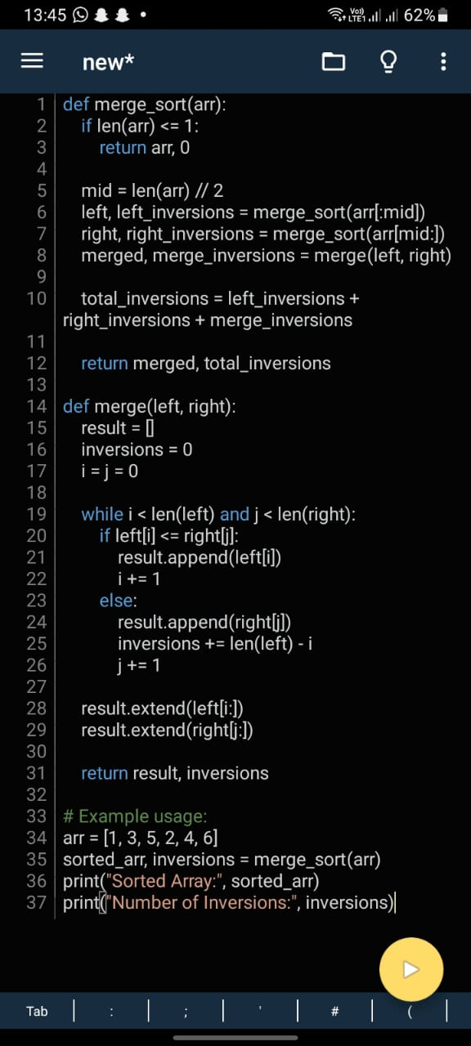

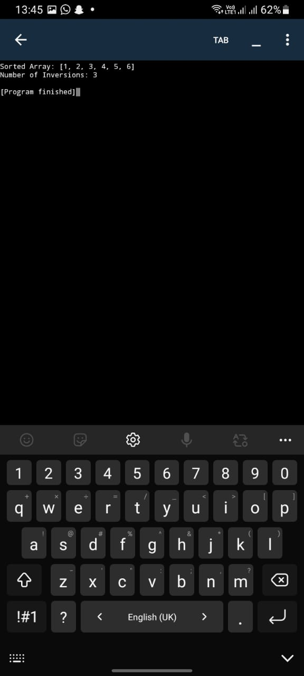

QUS#3: Modify the merge sort algorithm to sort a list in descending order instead of ascending order . this will require changes to the merging stepp. 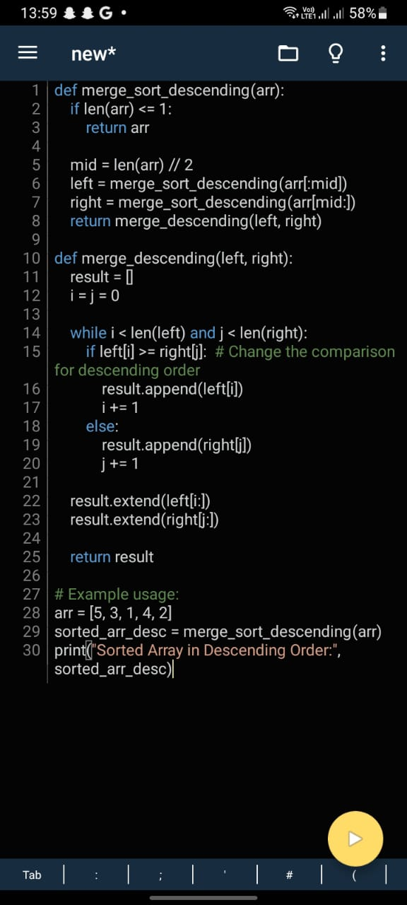

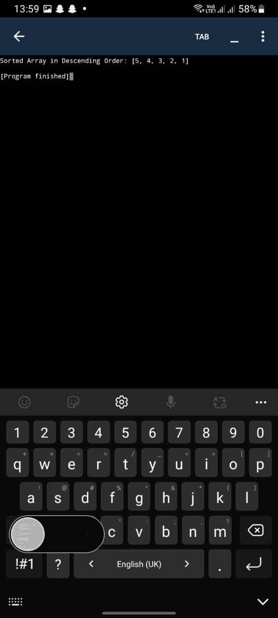

QUS#4: Extend the merge sort algorithm to work with three or more sublists at each step, not just two. This is called a three way ( or multi way) merge sort. 